**Machine Learning with Pyspark**

**Case Study Partner:**

Please use the screenshots ONLY as a reference. The written instructions must be followed AS written.

PLEASE MAKE SURE YOU SUBMIT ALL THE SCREENSHOTS WITH TIMESTAMPS AT THE BOTTOM RIGHT (WINDOWS USERS) OR THE TOP RIGHT (MAC OSX USERS) OR ELSE YOU WILL AUTOMATICALLY QUALIFY FOR A DISCOUNT.

# Objective:

PySpark is a great language for performing exploratory data analysis and building machine learning pipelines. MLlib is a Spark implementation of useful machine learning (ML) functionality. The objective of this case study is to become familiar with Pyspark. We will load the data in Pyspark and build a machine learning model using the K-Means algorithm.

Table of Contents

Objective: 1

Part-1: Creating Databricks account: 1

Part-2: Creating Cluster Node:: 1

Part-3: Create Data table:: 1

Part-4: Dataframe operations: 1

Part-5: Data Preprocessing: 1

Part-6 Implementation of K-means algorithm: 1

Part-7 Evaluate Mdel: 23

ADDITIONAL NOTES: 1

Part 1: Create a databricks account.

Step 1: Open the link:

<https://community.cloud.databricks.com/login.html>

Click on sign up.

Use your UT Dallas email id.

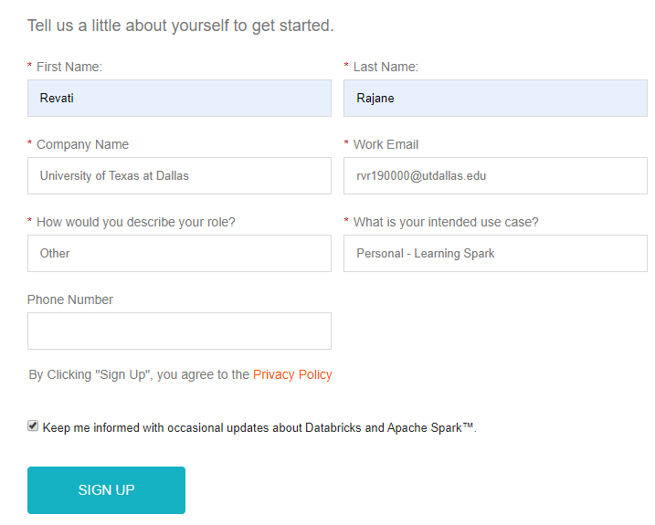

Step 2: Verify and confirm the databricks account from the email you have received from Databricks.

Go to the link again and click on “Sign In”.

Q. Login to your databricks account and take a screenshot of the Home page output and paste it below.

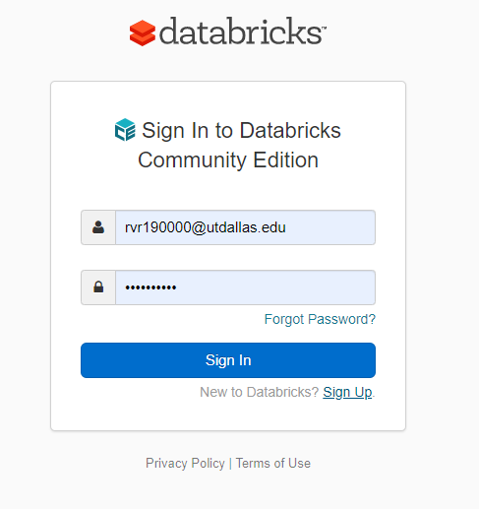

Part 2: Create a cluster node.

Step 3: Click on the “Clusters” icon as shown in the screenshot below:

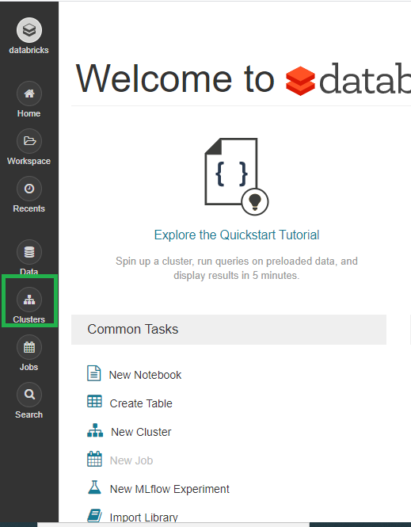

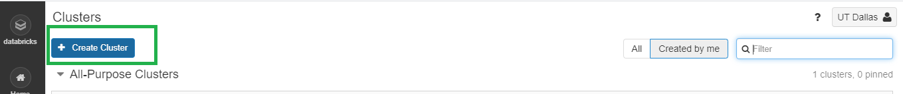

Step 4: Name the cluster as “FirstName_LastName_CaseStudy”.

Q. Take a screenshot of the Create Cluster page and paste it below.

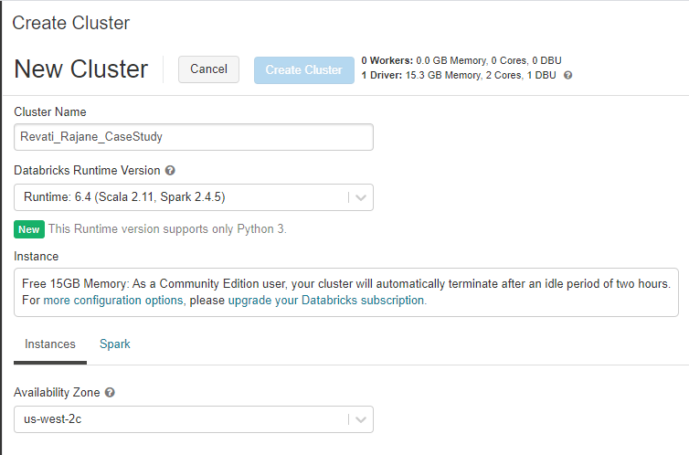

Explanation:

Here we are creating an all-purpose cluster that can be shared by multiple users. In this case you are the only user of the cluster.

NOTE:

1. Replace FirstName and LastName with your first name and last name, DO NOT copy it as is!

Step 5: Green sign shows that a cluster is created and running successfully.

Q. Take a screenshot of the running Cluster Page and paste it below.

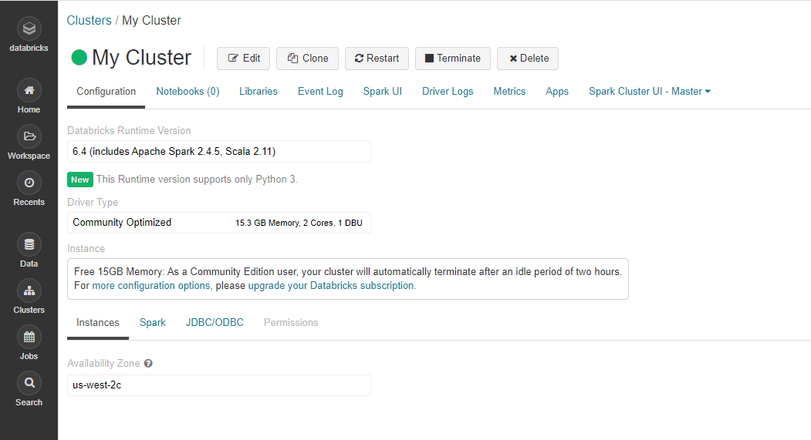

Part 3: Create Datatable.

Step 6: Download the “Bank.csv” file from eLearning.

Select the “Data” icon from the left panel and click on “Add Data”.

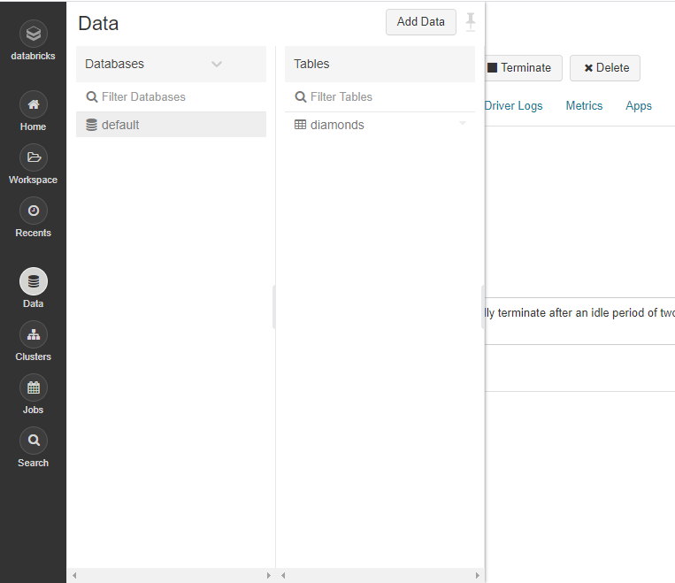

Step 7: Click on browse and select the “bank.csv” file that you downloaded from eLearning.

Take a screenshot of the uploaded file and paste it below.

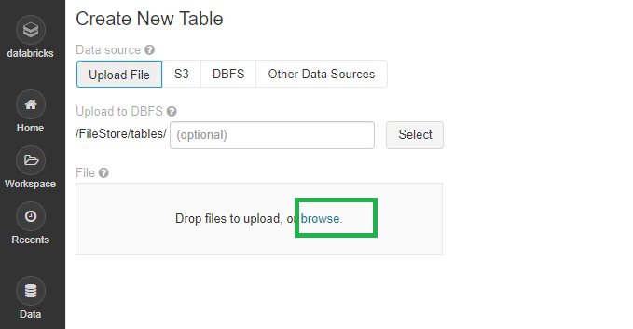

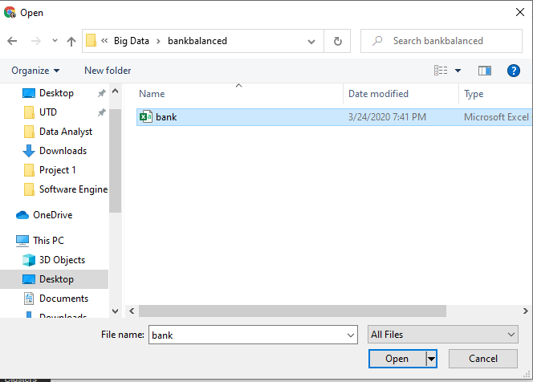

Step 8: Click on “Create Table in Notebook”.

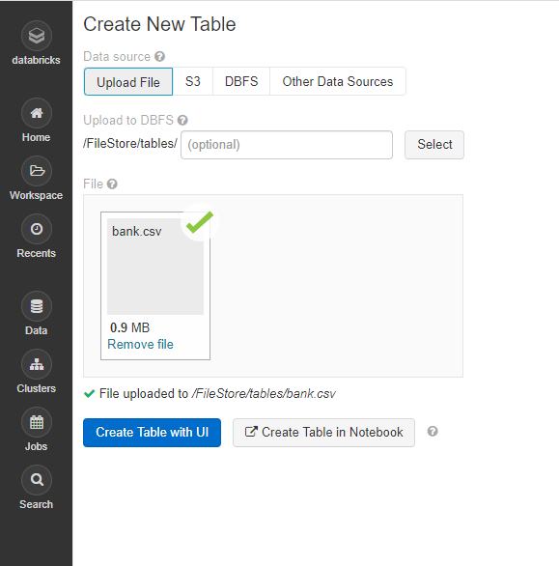

Step 9: The file location can now be seen.

Q. Take a screenshot of the table created and paste it below.

Copy the file location and paste it here.

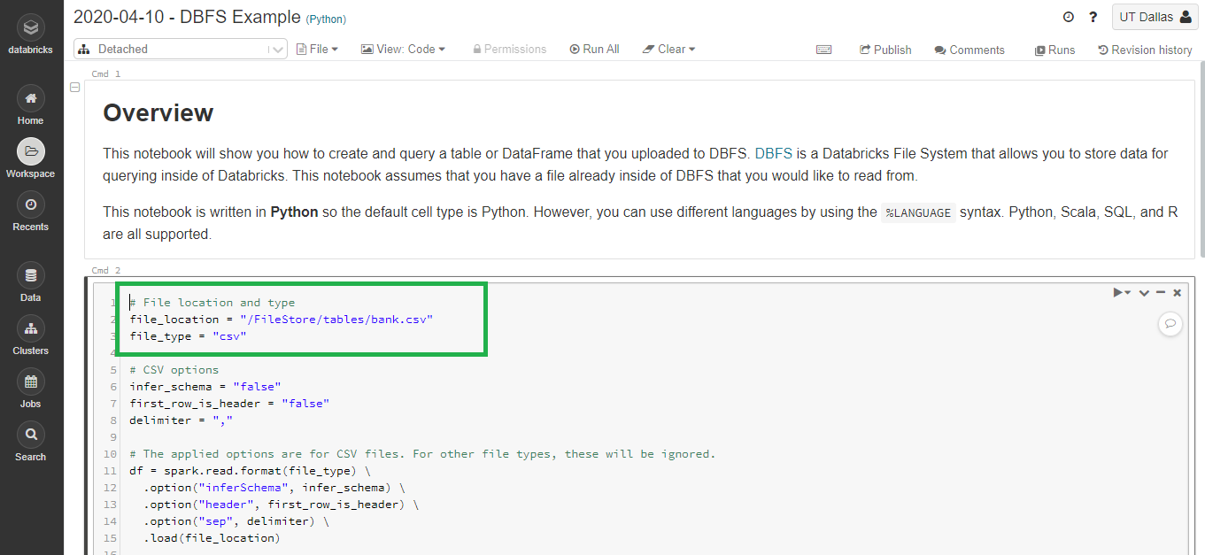

Explanation: A Databricks table is a collection of structured data. We had data in a CSV file which is not converted into a table. Also, you can View databases and tables by clicking 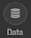 on the sidebar.

Part 4 : DataFrame Operations.

Step 10: Create new Notebook. Follow the steps below.

Click on “Databricks”. 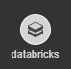

Click on “New Notebook”.

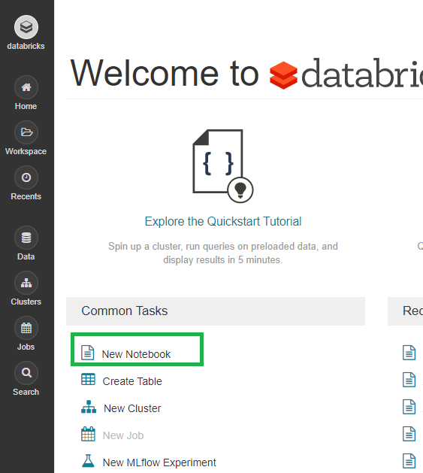

Explanation: A new notebook is created where we can write the pyspark code.

Step 11: Create the notebook with “FirstName_LastName_Pyspark”.

Language: “Python”

Cluster: Select the cluster we have created in part 1.

Q. Take a screenshot of the blank notebook and paste it below.

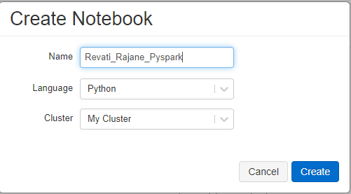

Explanation:

A notebook is a web-based interface to a document that contains executable code, visualizations, and narrative text.

NOTE:

1. Replace FirstName and LastName with your first name and last name, DO NOT copy as is!

Step 11: Import the required libraries from Spark.

Q. Take a screenshot of the output of the code and paste it below.

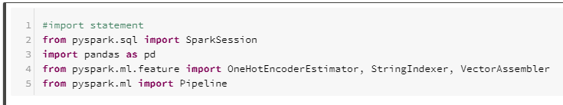

Click on the “Run Cell” option that is located in top right corner of the cell.

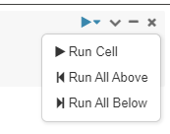

Explanation: Here all the required libraries for this assignment are imported.

Step 12:

Click on “+” sign at the end of the cell.



Type the code found below:

(Replace the path with your path that you copied in step 9)



Q. Take a screenshot of the output of the code and paste it below.

Here our output variable id is “deposit”. List all the input variables.

Explanation: “read.csv” is a function from spark library which reads the data from the table that we created in part 3. We have created a dataframe “df”.

Step 13: Type the code below in the next cell and Run the cell.

Q. Take a screenshot of the output of the code and paste it below.

i. Describe “Select”, “Group by” operations in one line.

ii. How many customers are there with an age greater than 40?

iii. Why are there only 5 records viewable?

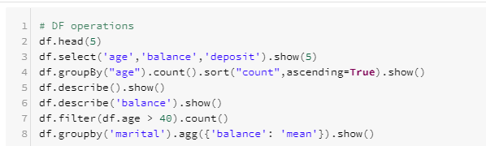

Step 14: Execute the following code:

Q. Take a screenshot of the output of the code and paste it below.

What is seen in the output of the transpose?

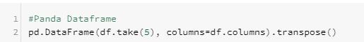

Explanation:

Here only 5 rows are considered, and transpose is performed on the dataframe.

Step 15: Execute the following code:

Q. Take a screenshot of the output of the code and paste it below.



Explanation:

Here summary statistics for the numeric values are printed.

Part 5: Data Preprocessing:

Step 16: Execute the following code:

Q. Take a screenshot of the output of the code and paste it below.

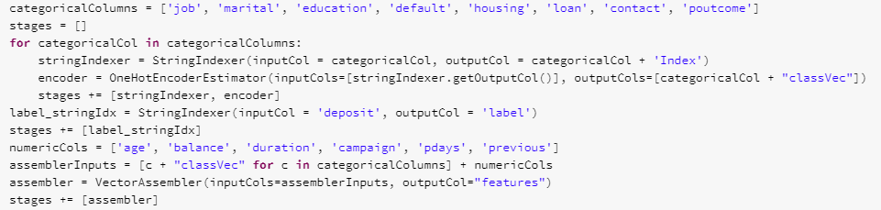

Explanation:

Line 1: All the categorical columns are listed.

Line 2: A blank array is created.

Line 3-7: Each categorical column it indexed using the StringIndexer, then converts the indexed categories into one-hot encoded variables.

Line 8-11: The output has the binary vectors appended to the end of each row. StringIndexer is used to encode the labels to label indices. VectorAssembler is used to combine all the feature columns into a single vector column.

Step 17: Execute the following code:

Q. Take a screenshot of the output of the code and paste it below.

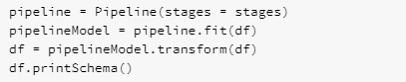

Explanation: Here we have defined a pipeline. We have described the steps of the pipeline in “stages”. “.fit” is used to fit the dataframe “df” to the pipeline.

Step 18: Execute the following command:

Q. Take a screenshot of the output of the code and paste it below.

Define the purpose of the transpose function?



Explanation: Here, the features column and label column which we have created in step 16 can be seen.

Step 19: Execute the following code:

Q. Take a screenshot of the output of the code and paste it below.

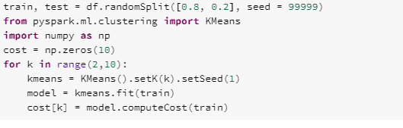

Explanation: Data is split in two parts, Train and Test 80% and 20% respectively. Here we are using for loop to calculate the cost of the K-means algorithm to decide how many clusters are required.

Step 20: Execute the following code:

Q. Take a screenshot of the output of the code and paste it below.

Comment about the graph that is plotted here.

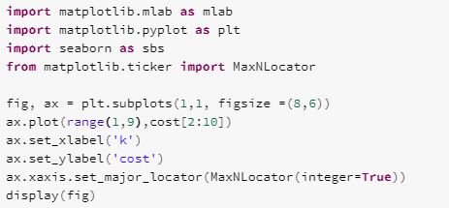

Explanation: matplotlib is a library which is used to plot a graph. Here we are plotting the graph of cost of K-means against number of clusters.

Set_xlabel and set_ylabel are used to set title on X axis and Y axis.

Reviewing the plotted curve, choose the optimum number of clusters.

Step 21: Execute the following code:

Q. Take a screenshot of the output of the code and paste it below.

The code below shows implementation of K means for 8 Clusters. As you will see, this model performs poorly with 8 clusters. We want to improve our model. Refer to the graph and implement the code below testing different numbers of clusters (for example cluster number = 3,4,5 etc.) to find the best model.

Refer to Step 21 and step 22 for the training dataset.

Refer to Step 24 and Step 25 for the testing dataset.

Show output of each cluster scenario that you evaluated.

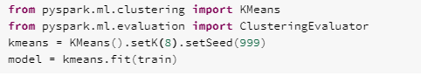

Explanation:

**KMeans().setK(3).setSeed(1)** :The number 8 is the number of clusters to divide the data into. After that model is fit to the train set.

Step 22: Execute the following code:

Q. Take a screenshot of the output of the code and paste it below.

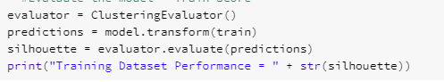

Explanation: predictions = model.transform(train) -This will add the prediction column to the dataframe, so we can show which customer qualifies for which category.

**ClusteringEvaluator()** is used to evaluate the training performance of the model with the training dataset.

Step 23: Execute the following code:

Q. Take a screenshot of the output of the code and paste it below.

What is Centroid and how is it calculated in K-means?

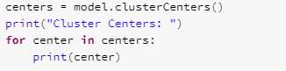

Explanation: We have print centroid of the clusters.

Step 24:

Execute the following code:

Q. Take a screenshot of the output of the code and paste it below.

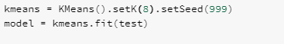

Explanation: Here we are fitting test dataset to K-means algorithm.

Step 25: Execute the following code:

Q. Take a screenshot of the output of the code and paste it below.

Copy the Train and Test performance results of all the clusters here. Compare the results and comment about the performance of each model. Select your best model and explain why you chose that number of clusters as the optimal level.

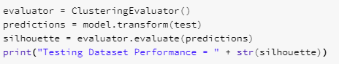

Step 26:

Export the file as “HTML” and save that with your “Firstname_Lastname” naming convention.

Convert this HTML file to PDF (This is your 2nd submission file)

Export as “IPNYB” file. (This is your 3rd submission file)

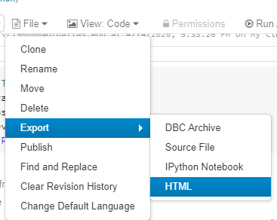

# ADDITIONAL NOTES:

* Make sure to check the spelling before you execute a code. A spelling mistake in one step can snowball and prevent other steps from working.
* **SUBMIT THREE FILES, 1) WORD DOCUMENT YOUR SCREENSHOTS 2) PDF FILE CREATED IN STEP 25 3) IPYNB FILE CREATED IN STEP 25.**
* **ALSO SUBMIT THE USERNAME OF YOUR DATABRICK’S ACCOUNT IN THE COMMENT BOX of your eLearning submission.**

